PMU Bank of Clothes Project
Introduction
Description:
The PMU Bank of Clothes is an online web platform designed to manage the collection and distribution of clothing at Prince Mohammad Bin Fahd University. The system provides a centralized digital environment where users can securely create accounts, log in, and interact with the university's clothing bank. It serves as an accessible bridge between individuals looking to donate gently used clothes and students who need specific clothing items.
Scope:
The scope of this project encompasses the requirements analysis, system design, prototyping, and partial implementation of the Bank of Clothes website. The system's core functionality is bound to user management (registration and authentication), donation submission, inventory cataloging, item requesting, and administrative approval workflows. The platform is designed to accommodate three specific user types: PMU students, external donors, and system administrators. The scope is strictly focused on the digital software management of the inventory and user requests, excluding the physical logistics of clothing storage, laundering, or physical delivery.
Objectives:
- To implement a centralized, intuitive online website to manage the Bank of Clothes in PMU.
- To streamline and digitize the process of clothes donations and their distributions, making it easier for students and visitors to participate.
- To provide a secure platform where users can easily create accounts and log in to the website.
- To equip university administrators with a dashboard system to efficiently approve incoming donations, track available inventory, and manage user activity.

Requirements Analysis
Stockholders:
The PMU Bank of Clothes system is designed to serve three primary groups of stakeholders:
- PMU Students: The primary consumers of the system can both browse the inventory to request clothing items and donate their own gently used clothes.
- External Donors: Individuals outside or inside the university who use the platform strictly to submit clothing donations.
- System Administrators: University staff or assigned student managers who oversee the platform, approve or reject incoming donations, and maintain the digital inventory.
User Stories:
- User Registration: As a new visitor, I want to create an account by providing my full name, PMU email, and role, so that I can securely access the platform.
- User Authentication: As a registered user, I want to sign in with my email and password so that my personal requests and donation history remain private.
- Role-Based Access Control: As an administrator, I want the system to recognize my role upon login so that I am routed to the management dashboard rather than the standard student view.
- Inventory Browsing: As a student, I want to view a visual catalog of all available clothing items so that I can see what is currently in stock.
- Search Functionality: As a student, I want to use a search bar to filter clothes by type or size so that I can quickly find exactly what I need.
- Admin Approval System: As an administrator, I want to view a table of pending donations and click "Approve" or "Reject" so that only acceptable items are added to the official inventory.
- Request Tracking: As a student, I want to access a "My Requests" page so that I can monitor the approval and delivery status of the clothes I have asked for.
- Administrative Reporting: As an administrator, I want to view user reports and manage the master inventory list so that I can keep track of stock levels and platform usage.
UML use-case diagram:
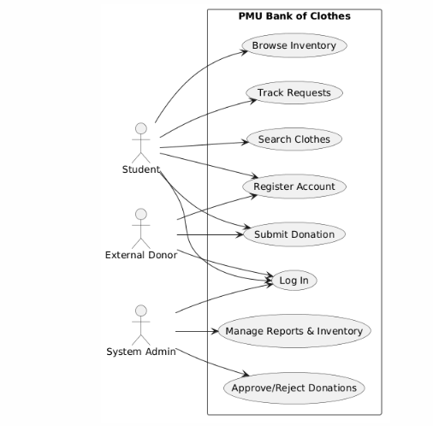
Non-functional requirements:
- Security
- Performance
- Usability
- Scalability

System Design
System architecture:
- Client side: This is the user interface accessible using web browsers. It is built using HTML5 and CSS3. This layer handles user inputs, displays the clothing inventory, and renders the administrative dashboards.
- Server side: The core logic of the system handled by a Node.js server running the Express.js framework. This layer acts as the middleman, processing HTTP requests from the client, enforcing role-based access control, validating PMU email addresses, and executing the business logic for donation approvals and item requests.
UML class diagram:
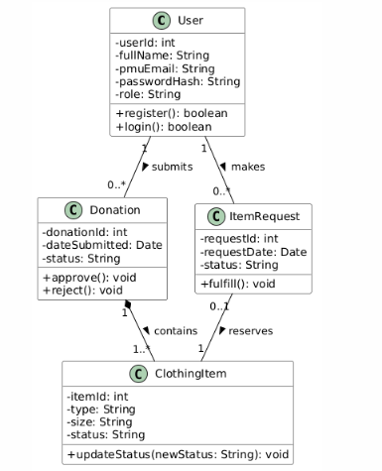

Database design (ER/Schema):
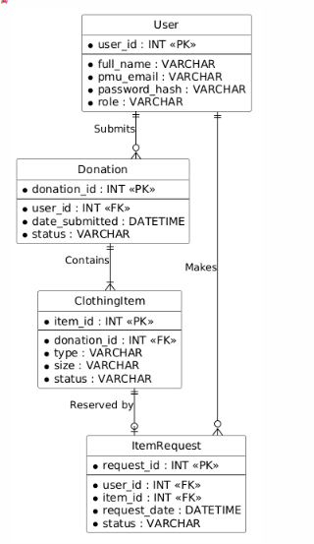

GUI Design (Figma):
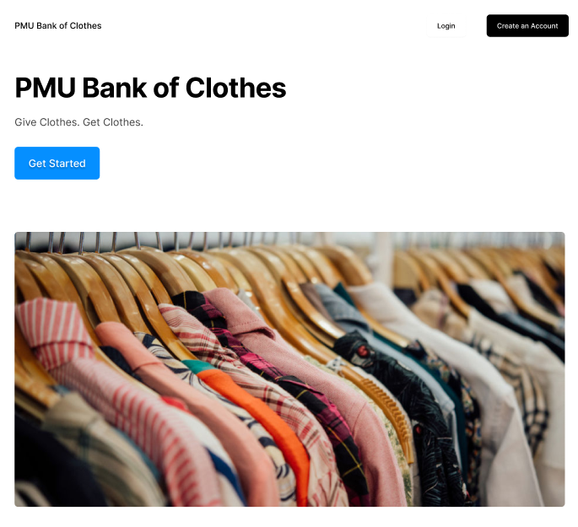
- Landing page:

- Login page
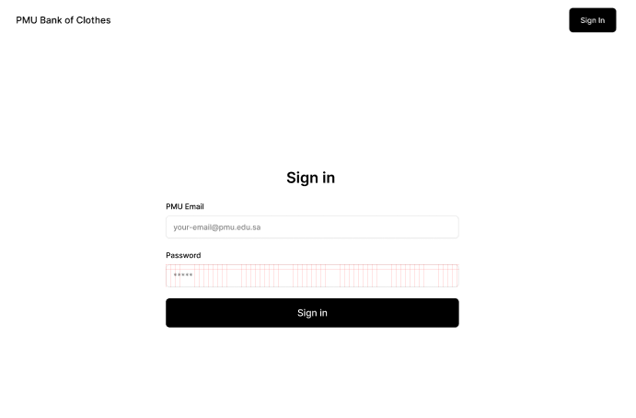

- Create an Account page

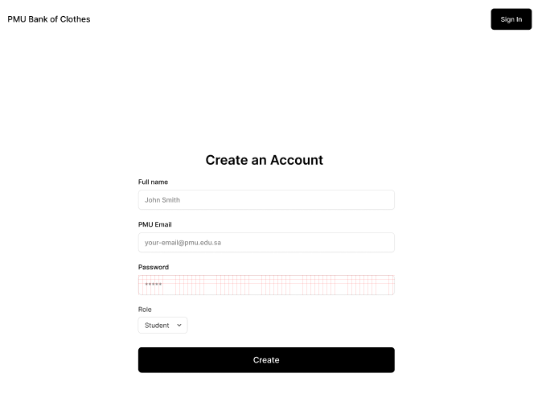

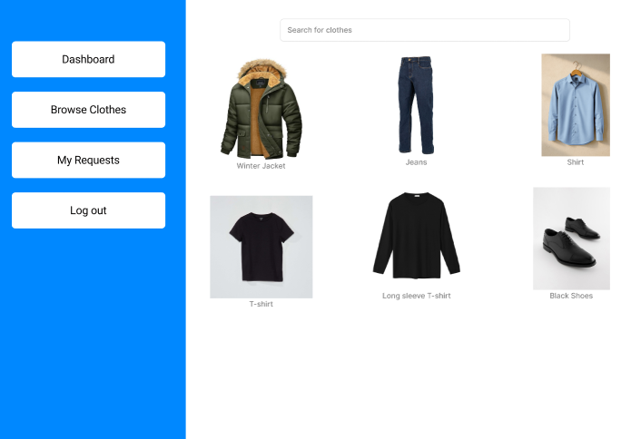
- Inventory

- Admin Dashboard

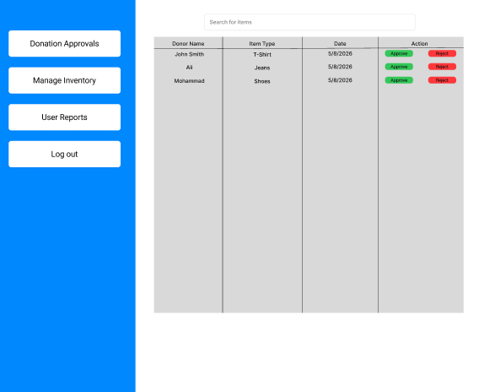

Link to Figma project: https://www.figma.com/design/wmi8WpAR5M1xAdUc0qzkDe/PMU-Bank-of-Clothes?node-id=0-1&t=9RcwFMNYIctY9oAg-1

Implementation
Description for implementation of the create account page:
The "Create Account" page was implemented using a lightweight Client-Server architecture. The frontend user interface was built from scratch using standard HTML5 and CSS3 to ensure a responsive, accessible design that matches the system's prototype.
The backend logic is powered by a Node.js server running the Express.js framework. The server.js file handles the routing and processes POST requests submitted from the registration form. It includes basic backend validation logic, specifically checking that users registering with the student role use a valid @pmu.edu.sa email address. For this initial prototype phase, user data is temporarily stored in an in-memory array to demonstrate successful data capture and routing without requiring a full database connection.

URL of the public GitHub repository:
https://github.com/Ethereal966/pmu-principles-project

Testing:
Feature | Test ID | Description | Expected Result | Status
User Registration | TC-1.1 | User enters valid name, valid PMU email, and password. | System successfully creates account and redirects to dashboard. | Pass
 | TC-1.2 | User selects Student role but enters a non-PMU email (e.g., @gmail.com). | System blocks registration and displays an error message. | Pass
User Authentication | TC-2.1 | User attempts to log in with correct registered credentials. | System grants access and loads the user's profile. | Pass
 | TC-2.2 | User attempts to log in with an incorrect password. | System denies access and displays an "Invalid Credentials" error. | Pass
Role-Based Access Control | TC-3.1 | A user with the Admin role logs in. | System routes the user to the Admin Approval Dashboard. | Pass
 | TC-3.2 | A user with the Student role attempts to access the Admin URL directly. | System blocks access and redirects the student back to the home page. | Pass
Inventory Browsing | TC-4.1 | Student navigates to the Browse Clothes page. | System successfully loads the visual grid of available clothing items. | Pass
 | TC-4.2 | Student navigates to the Browse Clothes page when the database is empty. | System displays a "No clothes currently available" message. | Pass
Search Functionality | TC-5.1 | Student searches for a specific item type (e.g., "Jacket"). | System filters the grid to show only items matching "Jacket". | Pass
 | TC-5.2 | Student searches for a nonexistent item type (e.g., "Tuxedo"). | System returns 0 results and prompts the user to try a different search. | Pass
Admin Approval System | TC-6.1 | Admin clicks the "Approve" button on a pending donation. | System updates the item status to "Approved" and adds it to the public inventory. | Pass
 | TC-6.2 | Admin clicks the "Reject" button on a pending donation. | System updates status to "Rejected" and notifies the original donor. | Pass
Request Tracking | TC-7.1 | Student clicks "Request Item" on an available piece of clothing. | System adds the item to the student's "My Requests" page with a "Pending" status. | Pass
 | TC-7.2 | Admin fulfills a student's request. | The item's status on the student's "My Requests" page updates to "Ready for Pickup". | Pass
Administrative Reporting | TC-8.1 | Admin accesses the Manage Inventory dashboard. | System displays the master list of all approved and pending stock. | Pass
 | TC-8.2 | Admin attempts to delete a clothing item record from the master inventory. | System removes the item from the database and updates the stock count. | Pass

Students: Muaid Aljaroudi 202301465 | Nawaf alzahrani 202301433 | Abdullah Alshadid 202300750 | Hazem Algarni 202201145

